EXPT NO:1 | Implementation of data charts
DATE: 06.01.2026 | Implementation of data charts

PRE-LAB QUESTIONS (PROVIDE BRIEF ANSWERS TO THE FOLLOWING QUESTIONS)

- How can visualization help an academic institution improve student outcomes?
Visualization helps institutions identify trends and patterns in student performance easily. It highlights weak subjects and underperforming students at a glance. Faculty can monitor progress over time and across departments. This enables timely academic support and improved learning outcomes.

- Which chart types are suitable for comparing subject-wise performance?
Bar charts are commonly used to compare marks across different subjects. Grouped bar charts allow comparison between multiple students or classes. Box plots help visualize score distribution and outliers. These charts make subject-wise performance comparison clear and effective.

- What type of data scale is used for student marks?
Student marks are measured using an interval scale of data. The difference between values is meaningful and consistent. However, there is no true zero that represents the absence of performance. Therefore, ratio-based comparisons are not applicable.

- Why should raw academic data be cleaned before visualization?
Raw academic data may contain missing values, duplicates, or errors. Such issues can lead to misleading or incorrect visualizations. Data cleaning ensures accuracy and consistency. This results in reliable and meaningful visual analysis.

- How does visualization support evidence-based decision making?
Visualization simplifies complex academic data into easy-to-understand visual formats. It helps identify trends, patterns, and anomalies quickly. Decisions can be made based on actual data rather than assumptions. This supports effective academic planning and policy making.
IN-LAB EXERCISE:
OBJECTIVE:
To design appropriate data charts to analyze and compare academic performance indicators.
SCENARIO:
An autonomous engineering college wants to analyze internal assessment performance of first-year students across five subjects to identify difficult courses and improve teaching strategies.
IN-LAB TASKS (Using R Language)
- Load required R libraries (ggplot2, dplyr)
- Import dataset using read.csv()
- Perform basic data preprocessing
- Create bar chart for subject-wise average marks
- Generate line chart for performance trend across tests
- Plot pie chart for grade distribution

(CODE: CONATAINS STUDENT ROLL NOS
SCREENSHOT OF CODE
SCREENSHOT OF OUTPUT)

CODE:
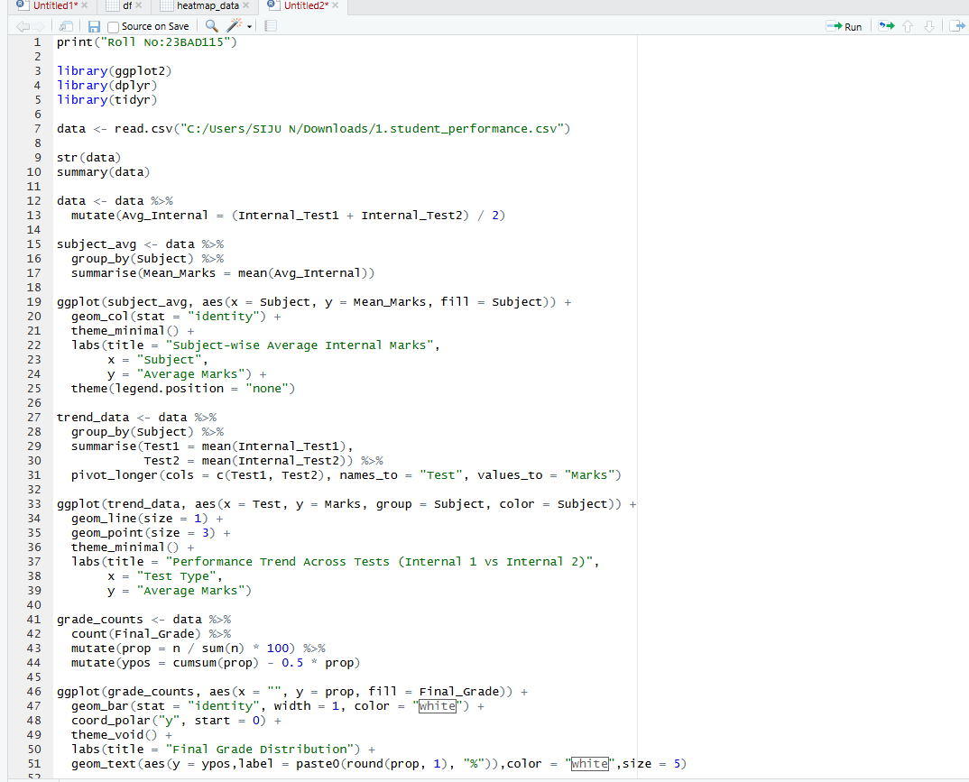

OUTPUT:

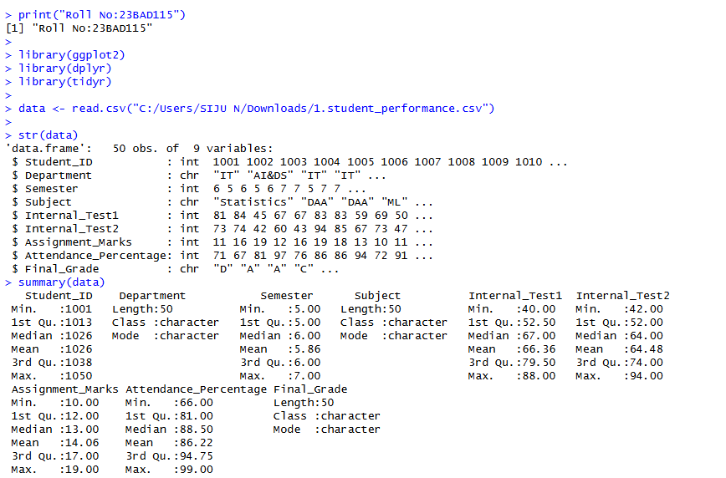

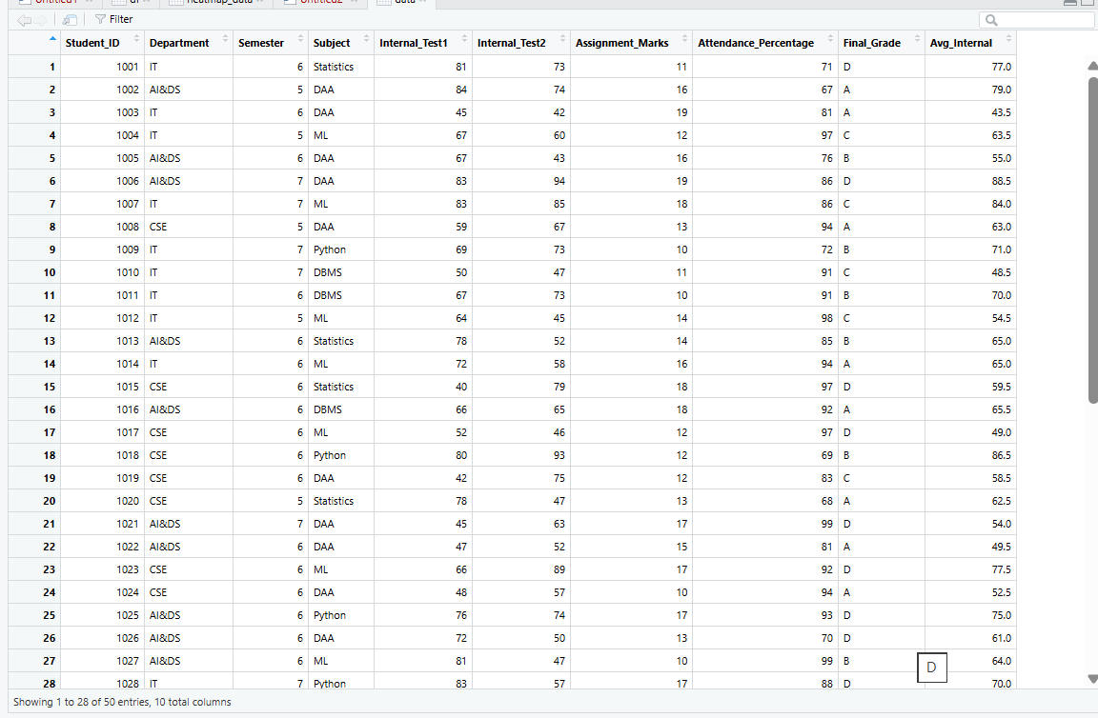

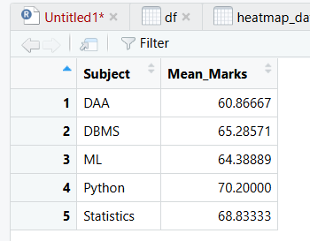

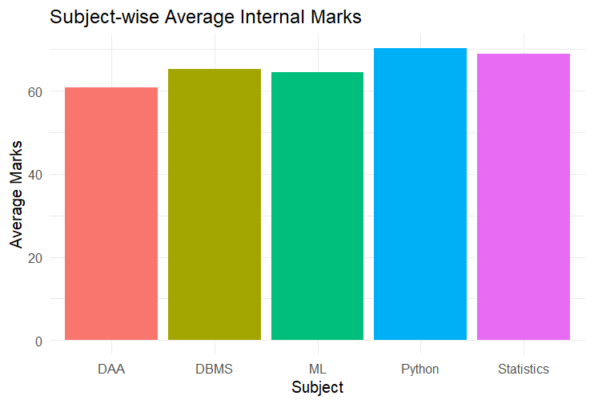
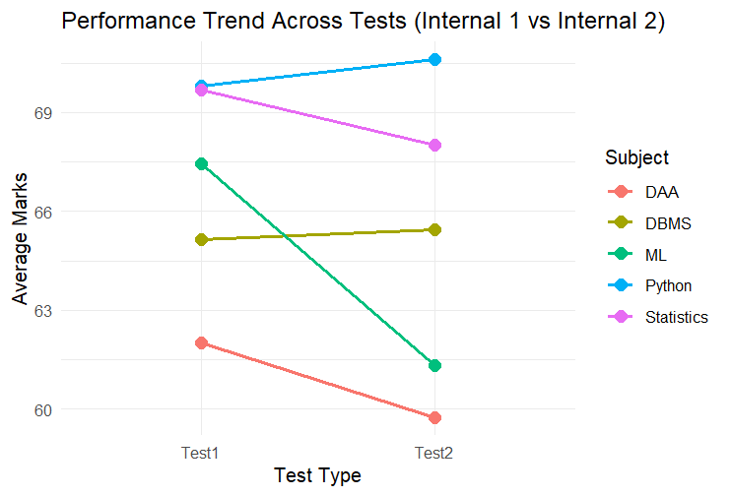

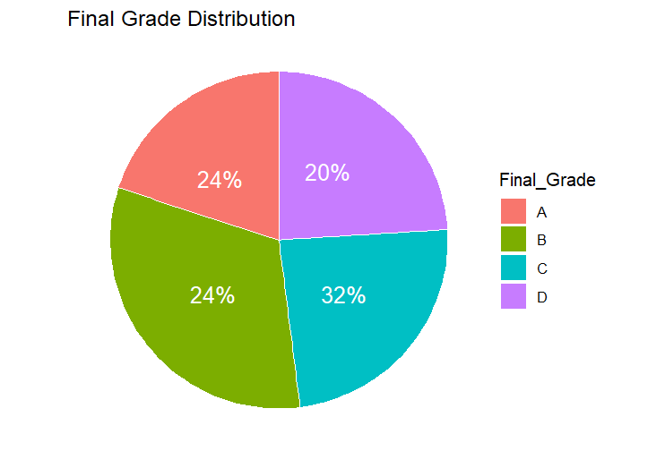

POST-LAB QUESTIONS (PROVIDE BRIEF ANSWERS TO THE FOLLOWING QUESTIONS)
- Which subject shows consistently low performance and why?
DAA demonstrates consistently low performance across evaluations. It records the lowest overall average score of 60.9 and shows weak results in both Internal Test 1 (62.0) and Internal Test 2 (59.7). This repeated underperformance indicates sustained difficulty with the subject rather than a one-time decline

- Why is a line chart suitable for trend analysis?
A line chart is well suited for trend analysis because it connects data points in a continuous manner. This makes changes between successive tests easy to observe. The direction of performance (increase or decrease) and the rate of change are clearly visible, enabling effective comparison across time.

- What limitations does a pie chart have in analytics?
Pie charts have several limitations in analytical tasks. They make it difficult to accurately compare similar values, especially when slice sizes are close. They also fail to represent changes over time and become cluttered and less readable when too many categories are included.

- How can this analysis help curriculum planning?
This analysis supports informed curriculum planning by identifying weak subjects and performance gaps. Knowing that subjects like DAA and ML showed poor results in Test 2 allows institutions to allocate additional tutorial hours, redesign course structure, or introduce preparatory sessions. Such adjustments help improve learning effectiveness.

- How can such visualizations be integrated into AI-driven academic analytics?
These visualizations can act as early warning indicators in AI-driven academic systems. AI models can analyze performance data in real time to predict students at risk of failure. Dashboards can automatically generate performance charts for faculty, enabling timely academic intervention before final assessments.

ASSESSMENT
Description | Max Marks | Marks Awarded
Pre Lab Exercise | 5
In Lab Exercise | 10
Post Lab Exercise | 5
Viva | 10
Total | 30
Faculty Signature

